**Period : Jun.17 – Jun.22, 2018**

**Pax : 7pax**

**Meals :No Pork/normal meals**

**Hotel : 4 Star local or Similar**

**5D4N ZHUHAI-SHENZHEN-HONGKONG TOUR**

17-JUN Upon arrival Hong Kong – visit ladies market , dinner ,check in hotel (D)

18-JUN Transfer to Lantau Island Tour – Cable Car Standard Cabins , Ngong Ping Village , Po Lin Monastery , Shopping at outlets (B/L/D)

19-JUN

Hong Kong City Tour – Victoria Peak by one-way Peak Tram, Aberdeen Fishing Village – Sampan ride on optional , The Golden Bauhinia Square , The Garden of stars .Evening transfer to Shenzhen by train ,Lo WU shopping mall , enjoy Dinner , check in hotel (B/L/D)

20-JUN Shenzhen City Tour - Splendid of china + 1 show

Transfer to Zhuhai by ferry (B/L/D)

21-JUN Zhuhai Tour - LOVER'S ROAD, FISHER GIRL STATUE, NEW YUAN MING YUAN GARDEN (without show).  Gongbei Underground Shopping Mall (B/L/D)

22-JUN

Transfer to to Macau , Visit Ruins of st.paul , A-Ma Temple , Senado Square , Lunch , drop off at ferry pier , take ferry to Hong Kong Airport (B/L)

**Shopping :  Shenzhen - Jade and herbal , Zhuhai - silk with Latex shop , Hong Kong – Jewellery Factory , chocolate , Macau – 1 souvenir shop**

**Hotel 4 **** local or Smiliar**

**HongKong：Panda Hotel**

[**http://hotels.ctrip.com/hotel/12577.html**](http://hotels.ctrip.com/hotel/12577.html)

**Shenzhen :Shenzhen Century Plaza or similar 4\***

<http://hotels.ctrip.com/hotel/425478.html>

**Zhuhai: Landmark International Hotel**

[**http://hotels.ctrip.com/hotel/47402.html**](http://hotels.ctrip.com/hotel/47402.html)

|  |  |  |  |  |
| --- | --- | --- | --- | --- |
| **PAX** | **4*local or similar** | | | |
| **TWN（USD）** | **SGL SUPL（USD）** | **CWB（USD）** | **CNB**  **（USD）** |
| **7** | **550 /pax** | **155** | **550/pax** | **460/pax** |

**Tour inclusion**

With coach and Indonesia Speaking guide

Meal : 4 x hotel breakfast , 8 x meal

Hong Kong – Shenzhen by train , Shenzhen – Zhuhai by ferry , Macau – Hong Kong Airport by ferry

2 night hotel accommodation at Panda Hotel or similar 4*

1 night hotel accommodation at Shenzhen Century Plaza Hotel or similar 4*

2 nights hotel accommodation at Zhuhai Landmark Hotel or similar 4*

**The above quotation excluded:**

1. International flight ticket and airport tax

**2. Tips for the guide and driver USD 5 /pax/day.**

3. Tips for potter, waitress & Luggage’s fee

4. Personal consumptions & expenses (laundry, phone, mini bar, etc)

**REMARKS:**

* Price is not available at Chinese National Holiday/Festival or big events (negotiable)

* The above rates are unavailable for groups of students, university, travel agent family / staff, airline staffs

* Child 12 year old – up with bed, price same as adult

**Dibawah ini merupakan Foto manager Phoenix Tour, Ibu Alice. Beliau dapat berbahasa Indonesia. Selama perjalanan anda dan tamu di China, jikalau ada masalah apapun, dapat langsung menghubungi manager kami. Sehingga kami juga dpat langsung menyelesaikan masalah anda, dan kami menjamin untuk menjaga kualitas serta menghindari segala komplain tamu.**

**Alice Dong +86 13701189684 (mobile phone, whatapp, we chat)**

**+ 86-10-84859932**

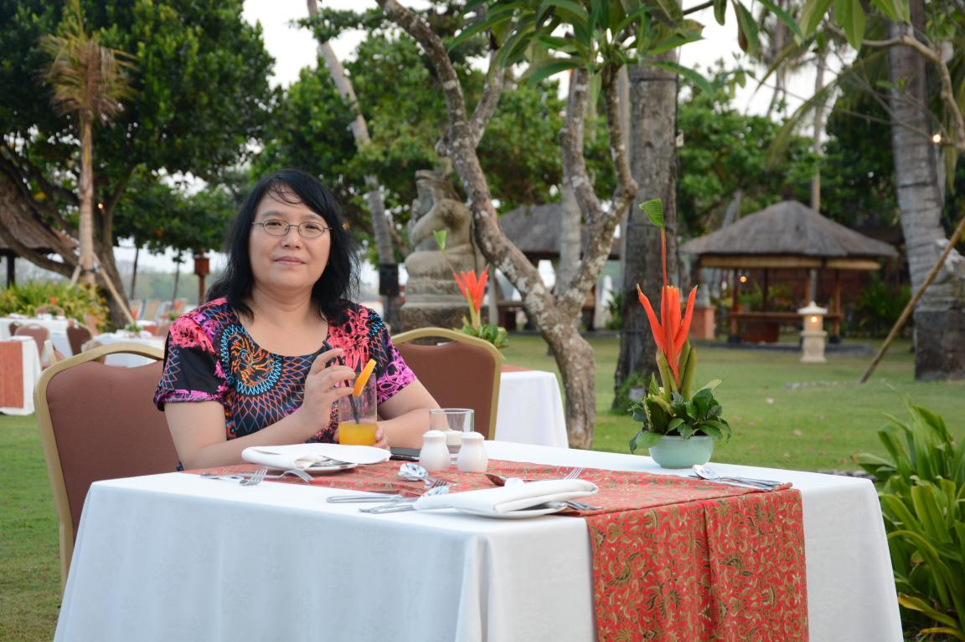

**2018.05.17**